

National College of Ireland

<Academic Year i.e. 2020/2021>

**<Eskandar>, <23137517>,** [**<x23137517@student.ncirl.ie**](mailto:%3cx23137517@student.ncirl.ie)**>**

**<Alex>, <22440482>,** [**<x22440482@student.ncirl.ie**](mailto:%3cx22440482@student.ncirl.ie)**>**

**<Joshua>, <23153920>,** [**<x23153920@student.ncirl.ie**](mailto:%3cx23153920@student.ncirl.ie)**>**

**<Yonas>, <23154454>, <x23154454@student.ncirl.ie>**

**<**[**Market-Live-Prices-Team-Project**](https://github.com/EskandarAtrakchi/Market-Live-Prices-Team-Project) **>**

Technical Report

Contents

Executive Summary 1

1.0 Introduction 1

1.1. Background 1

1.2. Aims 1

1.3. Technology 1

2.0 System 1

2.1. Requirements 1

2.1.1. Functional Requirements 1

2.1.1.1. Use Case Diagram 1

Requirement 1 <Crypto ID Retrieval> 4

Requirement 2 <Crypto Bubbles> 5

Requirement 3 <Fear and Greed index> 5

Requirement 4 <User Public Chat> 6

Requirement 5 < Price Retrieval > 6

2 Use Case 6

Requirement 6 Feedback 7

2.1.2. Data Requirements 7

2.1.3. User Requirements 8

2.1.4. Environmental Requirements 8

2.1.5. Usability Requirements 8

2.2. Design & Architecture 8

2.3. Implementation 8

2.4. Graphical User Interface (GUI) 8

2.5. Testing 10

3.0 Further Development 10

4.0 References 10

5.0 Appendices 10

5.1. Collaboration Summary 10

# Executive Summary

This technical report document will be detailed by the team knowing that each team member did their part on the document. This document is subject to change if the team decides to make modifications/changes to the product.

The porpuse of this report is to present the project that we have built, the technologies we have used, and the architecture of the project.

We will define the aim, system mechanisms used, codes, and requirements.

We will try to publish the testing results then the conclusion of all above.

# Introduction

## Background

The blockchain technology is evolving every single day and, and it is growing at a very fast scale, the crypto market is setting at 2.8 trillion dollars at the time of writing this document.

## Aims

We aim to enter the industry by providing services, as the market is volatile trades or anyone on earth who want to know the prices of cryptocurrencies the can by just visting our website!

## Technology

We have used the following technologies:

|  |  |
| --- | --- |
| **Frontend** | **Backend** |
| HTML | Express.js |
| CSS | CORS.js |
| Bootstrap | Nodemon |
| JavaScript | Node.js |
| Chart.js | Socket.io |
|  | Origins |
|  | Axios |
|  | HTTPS |
|  | localStorage |

# System

## Requirements

The system targets those who want real-time information without the need for registration or their private details. A feedback mechanism will be implemented to take it fully from user’s perspective and see what the market requires.

Description: Users should be able to receive real-time updates on the prices of selected cryptocurrencies. The system must provide accurate and up-to-date information, including the current market price in US dollars.

Rationale: Individual investors and traders need timely information to make informed decisions. Real-time updates ensure that users have the latest data to react to market changes promptly. The users should be able to retrieve crypto ID numbers with the same name of cryptocurrency from the crypto market. Users can see the frame of crypto bubbles from the webpage.

## Functional Requirements

This section lists the functional requirements in **ranked order**. Functional requirements describe the possible effects of a software system, in other words, what the system must accomplish. Other kinds of requirements (such as interface requirements, performance requirements, or reliability requirements) describe how the system accomplishes its functional requirements. Each functional requirement should be specified in a format similar to the following:

Short, imperative sentence stating highest ranked functional requirement.

## Use Case Diagram

Main

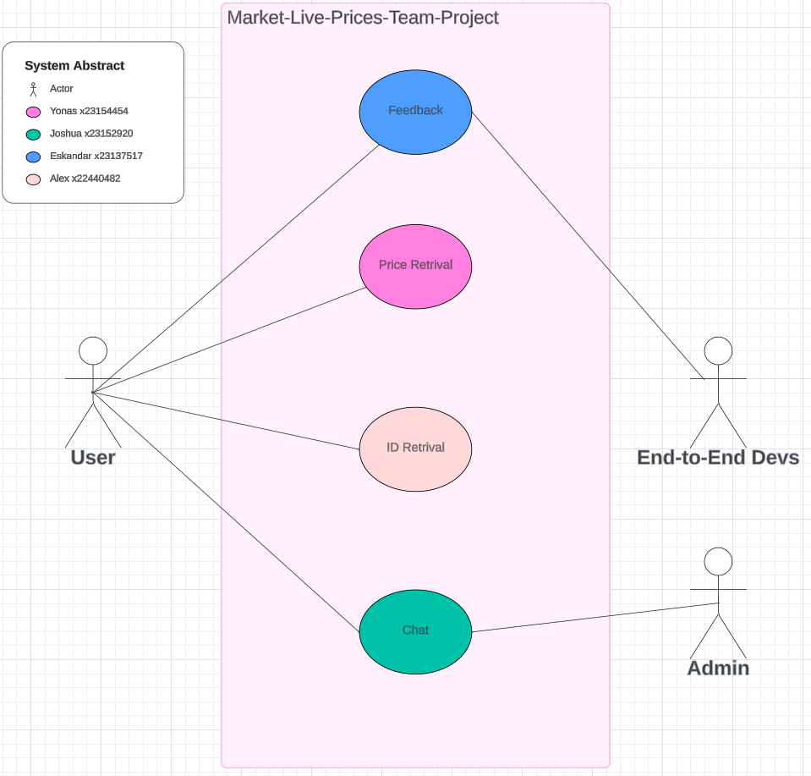

Overall system abstract

FeedBack

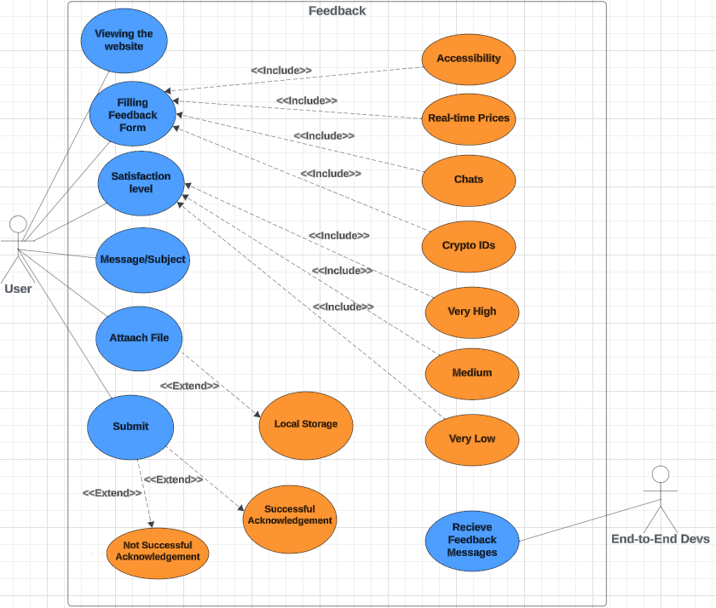

Eskandar Use case Diagram

1. Viewing the website: after the user interacts with the product, they can submit their feedback form.
2. Filling feedback form: the user will be prompt to a form to fill and submit, with in the form the user must choose one of the following categories: Accessibility, Real-time Prices, Chats, and Crypto IDs
3. Message/subject: to fill out a message attached with the feedback.
4. Satisfaction level: the user can select very high, medium, or very low.
5. Attach file: the user will be able to to select a file from their local storage.
6. Submit: the user will submit their feedback and an acknowledgement will be sent

Price Retrieval

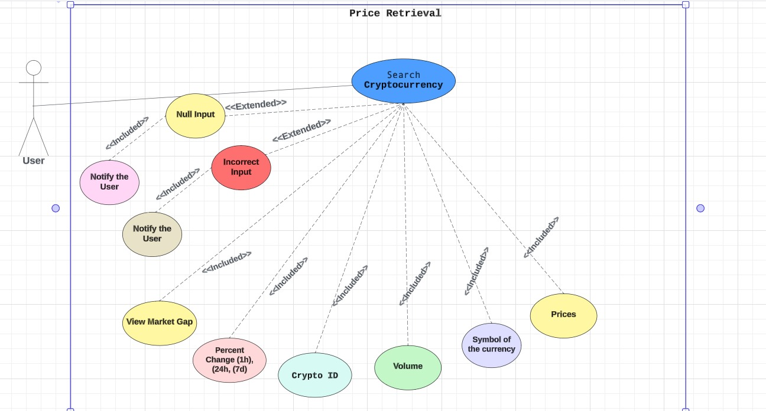

Yonas Use case Diagram

1. The user will interact with the website page to search crypto prices using the name.
2. If the user input null or wrong input the system will inform them to try again with correct information.
3. If the user input correct information the system will fetch the data with expected functionality.

ID Retrieval

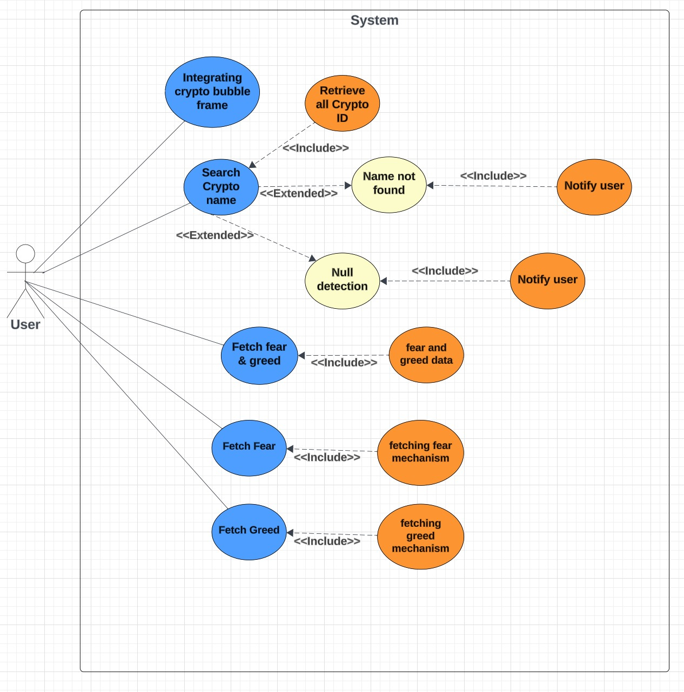

Public Chat

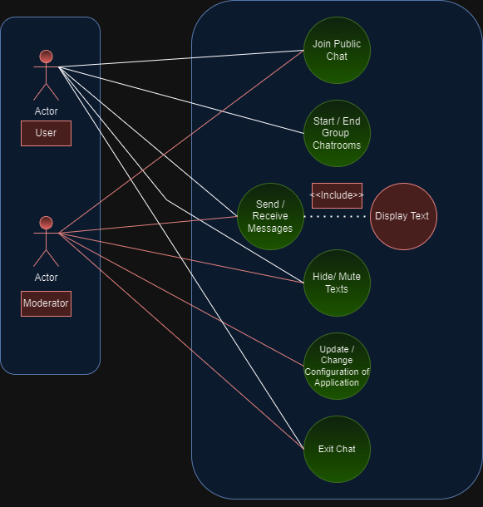

1.User joins public chat.

2.User has an option in starting or ending a group chat (private room) where you can text selected users.

3.User sends and receives messages to other users, which gets displayed. onto the public chat.

4.User can hide text (delete) his own text message if need be.

5.Developer can update, modify, and delete the software of the chat application.

6.User can exit chat.

### Requirement 1 <Crypto ID Retrieval>

The heading of this section should read, e.g., “Requirement 1: User registration” or “Requirements 1: Participant takes test”

#### Description & Priority

A description of the requirement and its priority. Describes how essential this requirement is to the overall system.

#### Use Case

Each requirement should be uniquely identified with a sequence number or a meaningful tag of some kind.

**Scope**

The scope of this use case is to allow users to retrieve the ID number by using API for any cryptocurrency that exists in the crypto market.

**Description**

This use case describes the ID number that refers to the ID listing. For that reason, for any type of cryptocurrency with the same name, all crypto IDs will be retrieved and the bar charts will compare the smaller ID number of the cryptocurrency the higher prices of the currency that we have.

**Flow Description**

**Precondition**

The system is in initialisation mode, ready to receive the ID number from the crypto market

**Activation**

This use case starts when a user enters a textbox to retrieve the ID numbers of a cryptocurrency.

**Main flow**

1. The system identifies the crypto IDs that will be retrieved.
2. The user enters the crypto name in the textbox to retrieve the crypto ID of the cryptocurrency.
3. The system retrieves all crypto IDs that will be associated with cryptocurrency from the crypto market
4. The user receives the crypto IDs from the API system.

**Alternate flow**

A1 : < Crypto Name Not Found>

1. The system fails to find cryptocurrency
2. The user receives an error message
3. The use case continues at position 3 of the main flow

**Exceptional flow**

E1 : <System Error>

1. The system notifies the developers of an unexpected error when the crypto ID is retrieved.
2. The user receives the error message
3. The use case continues at position 4 of the main flow

**Termination**

The system presents the next of crypto IDs with bar charts.

**Post condition**

The system goes into a wait state, ready to process the API to retrieve the data.

### Requirement 2 <Crypto Bubbles>

#### Description & Priority

A description of the requirement and its priority. Describes how essential this requirement is to the overall system.

#### Use Case

Each requirement should be uniquely identified with a sequence number or a meaningful tag of some kind.

**Scope**

The scope of this use case is to integrate cryptocurrency bubbles on the webpage.

**Description**

This use case describes the process of retrieving cryptocurrencies and display the crypto bubbles on the webpage.

**Flow Description**

**Precondition**

The system is in initialization mode using API to retrieve cryptocurrencies.

**Activation**

This use case starts when a user searches for cryptocurrency from crypto bubbles.

**Main flow**

1. The system identifies the API to fetch crypto bubbles.
2. The user integrates with the crypto bubbles.
3. The system retrieves the cryptocurrency data from the API.
4. The user views the crypto bubbles from the webpage.

**Alternate flow**

A1 : <Failed to display>

1. The system fails to display the crypto bubbles on the webpage
2. The user receives an error message.
3. The use case continues at position 3 of the main flow

**Exceptional flow**

E1 : <title of E1>

1. The system notifies the developers of an unexpected error when the crypto bubbles is not displayed on the webpage
2. The user receives the error message
3. The use case continues at position 4 of the main flow

**Termination**

The system presents the next crypto bubbles to the user.

**Post condition**

The system goes into a wait state, ready to process the API to retrieve the data.

### Requirement 3 <Fear and Greed index>

#### Description & Priority

A description of the requirement and its priority. Describes how essential this requirement is to the overall system.

#### Use Case

Each requirement should be uniquely identified with a sequence number or a meaningful tag of some kind.

**Scope**

The scope of this use case is to retrieve the Fear and Greed index from the crypto market.

**Description**

This use case describes the process of displaying the Fear and Greed index on the webpage.

**Flow Description**

**Precondition**

The system is in initialisation mode, the API is ready to retrieve the Fear and Greed index.

**Activation**

This use case starts when a user retrieves the Fear and Greed index chart from API.

**Main flow**

1. The system identifies the API to fetch the Fear and Greed index.
2. The user integrates with the Fear and Greed index.

**Alternate flow**

A1 : <title of A1>

1. The system fails to display the Fear and Greed index on the webpage
2. The user receives the error message.
3. The use case continues at position 3 of the main flow

**Exceptional flow**

E1 : <title of E1>

1. The system notifies the developers of an unexpected error when the Fear and Greed index is not displayed on the webpage
2. The user receives the error message
3. The use case continues at position 4 of the main flow

**Termination**

The system presents the next Fear and Greed index to the user.

**Post condition**

The system goes into a wait state.

### Requirement 4 <User Public Chat>

#### Description & Priority

A description of the requirement and its priority. Describes how essential this requirement is to the overall system.

#### Use Case

Each requirement should be uniquely identified with a sequence number or a meaningful tag of some kind.

**Scope**

The scope of this use case is to provide a user public chat where people can interact and give each other their opinions.

**Description**

This use case describes the public chat that will appear on the website.

**Flow Description**

**Precondition**

The system is in initialisation mode when user enters the website and joins chat.

**Activation**

This use case starts when the user sends a message within the public chat.

**Main flow**

The normal flow

1. The system identifies the user.
2. The user is able to send and receive messages.

**Alternate flow**

What happens if it goes the opposite as intended.

1. The system does not let the user join.
2. The user isn’t able to send messages or receive them.

**Exceptional flow**

1. The system notifies the user of chat errors.
2. The user can restart the webpage/
3. The use case continues at position 4 of the main flow

**Termination**

The system presents the next sent message, or exits the public chat.

**Post condition**

The system goes into a wait state

### Requirement 5 < Price Retrieval >

3.1.1.1 **Description**

Searching crypto data and prices: user will be able to search the cryptocurrency by searching the name of the crypto, and if they user input the correct name of the currency the system will display the crypto data.

### 2 Use Case

**Scope:** The scope of this use case is to enable users to retrieve cryptocurrency data and prices through a search functionality.

**Description:** This use case describes how users can search for cryptocurrency data and prices by entering the name of the cryptocurrency they are interested in. The system will then display the relevant data for the searched cryptocurrency.

**Flow Description Precondition:**  The system is initialized and has access to real-time cryptocurrency data.

**Activation:** This use case starts when a user triggers the search functionality by entering the name of a cryptocurrency.

**Main Flow**

1. The system identifies the user's input as a search query for cryptocurrency data.
2. The system validates the user's input to ensure it matches the name of an existing cryptocurrency.
3. If the user input matches the name of a cryptocurrency:
   * The system retrieves the relevant data and prices for the searched cryptocurrency.
   * The system displays the cryptocurrency data to the user.

**Alternate Flow A1:** If the user input does not match the name of any existing cryptocurrency:

1. The system notifies the user that the entered cryptocurrency name is not recognized.
2. The system prompts the user to enter a valid cryptocurrency name.
3. The use case continues at position 2 of the main flow.

Exceptional flow E1: If there is an error retrieving cryptocurrency data:

1. The system displays an error message indicating that cryptocurrency data could not be retrieved.
2. The system prompts the user to try again later or contact support for assistance.
3. The use case continues at position 2 of the main flow.

### Requirement 6 Feedback

#### Description & Priority

Priority is the lowest however, Feedback mechanism is very important for us to meet the user experience and for system evolution in the future to add more functionalities to the website, feedback will release the product potential if the feedbacks taken seriously.

The environment that we are working on is volatile especially dealing with crypto currencies, attention to user feedback is important.

#### Use Case

After the user view the website, the user can submit their feedback as the following:

1.The user can select the section that they want to submit their feedback form for and the sections are: Accessibility, real-time prices, chats, and crypto IDs

2.Satisfaction level: there are three levels scale and they are: very high, medium, and very low

3.Attach file: if the user wants to attach file from their local device, for example the user can take a screenshot for the meant part and submit it with their feedback process.

4.Subject: the user can write a message if they want to.

5.The team will receive the feedback that was submitted by the user to develop the product accordingly.

**Scope**

The scope of this use case is to provide feedback mechanism for the users to keep developing the system for better user experience and future system evolution.

**Description**

This use case describes the process of collecting and processing feedback from users regarding a particular feature or functionality within the system.

**Flow Description**

**Precondition**

The system is in initialization mode, ready to receive feedback from users.

**Activation**

This use case starts when a user initiates the feedback process.

**Main flow**

1. The system identifies the specific area or feature for which feedback is being provided.
2. The user shares their feedback and provides relevant details.
3. The system processes the feedback, recording relevant information for analysis.
4. The user receives acknowledgment or confirmation of their submitted feedback.

**Alternate flow**

1. The system encounters a specific condition in which additional steps are required.
2. The user follows the specified steps to address the condition.
3. The use case continues at position 3 of the main flow.

**Exceptional flow**

1. The system encounters an exceptional condition that requires special handling.
2. The user follows the prescribed steps to resolve the exceptional condition.
3. The use case continues at position 4 of the main flow.

**Termination**

The system presents the next steps or information relevant to the feedback process to terminate.

**Post condition**

The system transitions into a wait state, ready to receive further feedback.

1. The feedback system should provide a user-friendly interface for input.
2. The system able to capture files and include them with the submission.
3. Feedback of the users will be stored for future system evolution.
4. The acknowledgment to the user may include a reference number for tracking purposes.

## Data Requirements

## User Requirements

## Environmental Requirements

## Usability Requirements

## Design & Architecture

Describe the design, system architecture and components used. Describe the main algorithms used in the project. (Note use standard mathematical notations if applicable).

An architecture diagram may be useful. In case of a distributed system, it may be useful to describe functions and/or data structures in each component separately.

## Implementation

Describe the main algorithms/classes/functions used in the code. Consider to show and explain interesting code snippets where appropriate.

1. Backend   
   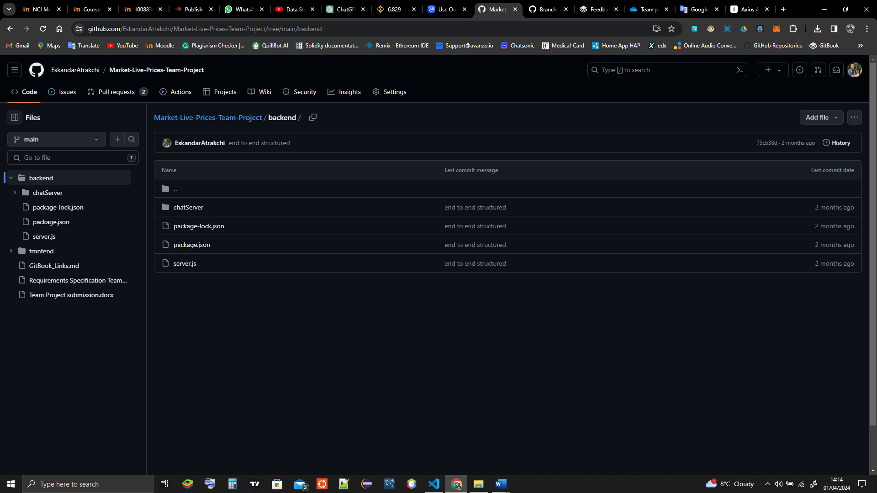

The backend is running on two servers the first server is for the API price retrievals and the second server is for the chat message broadcasting, each server has its own dependencies formatted in JSON file just like this

{

    "dependencies": {

      "axios": "^1.6.7",

      "cors": "^2.8.5",

      "express": "^4.18.2",

      "http": "^0.0.1-security",

      "nodemon": "^3.1.0"

    }

}

This will allow the program to know what we are using instead of loading the project with a lot of files which will make the project slow down to the level might not even be useable!

1. Frontend  
   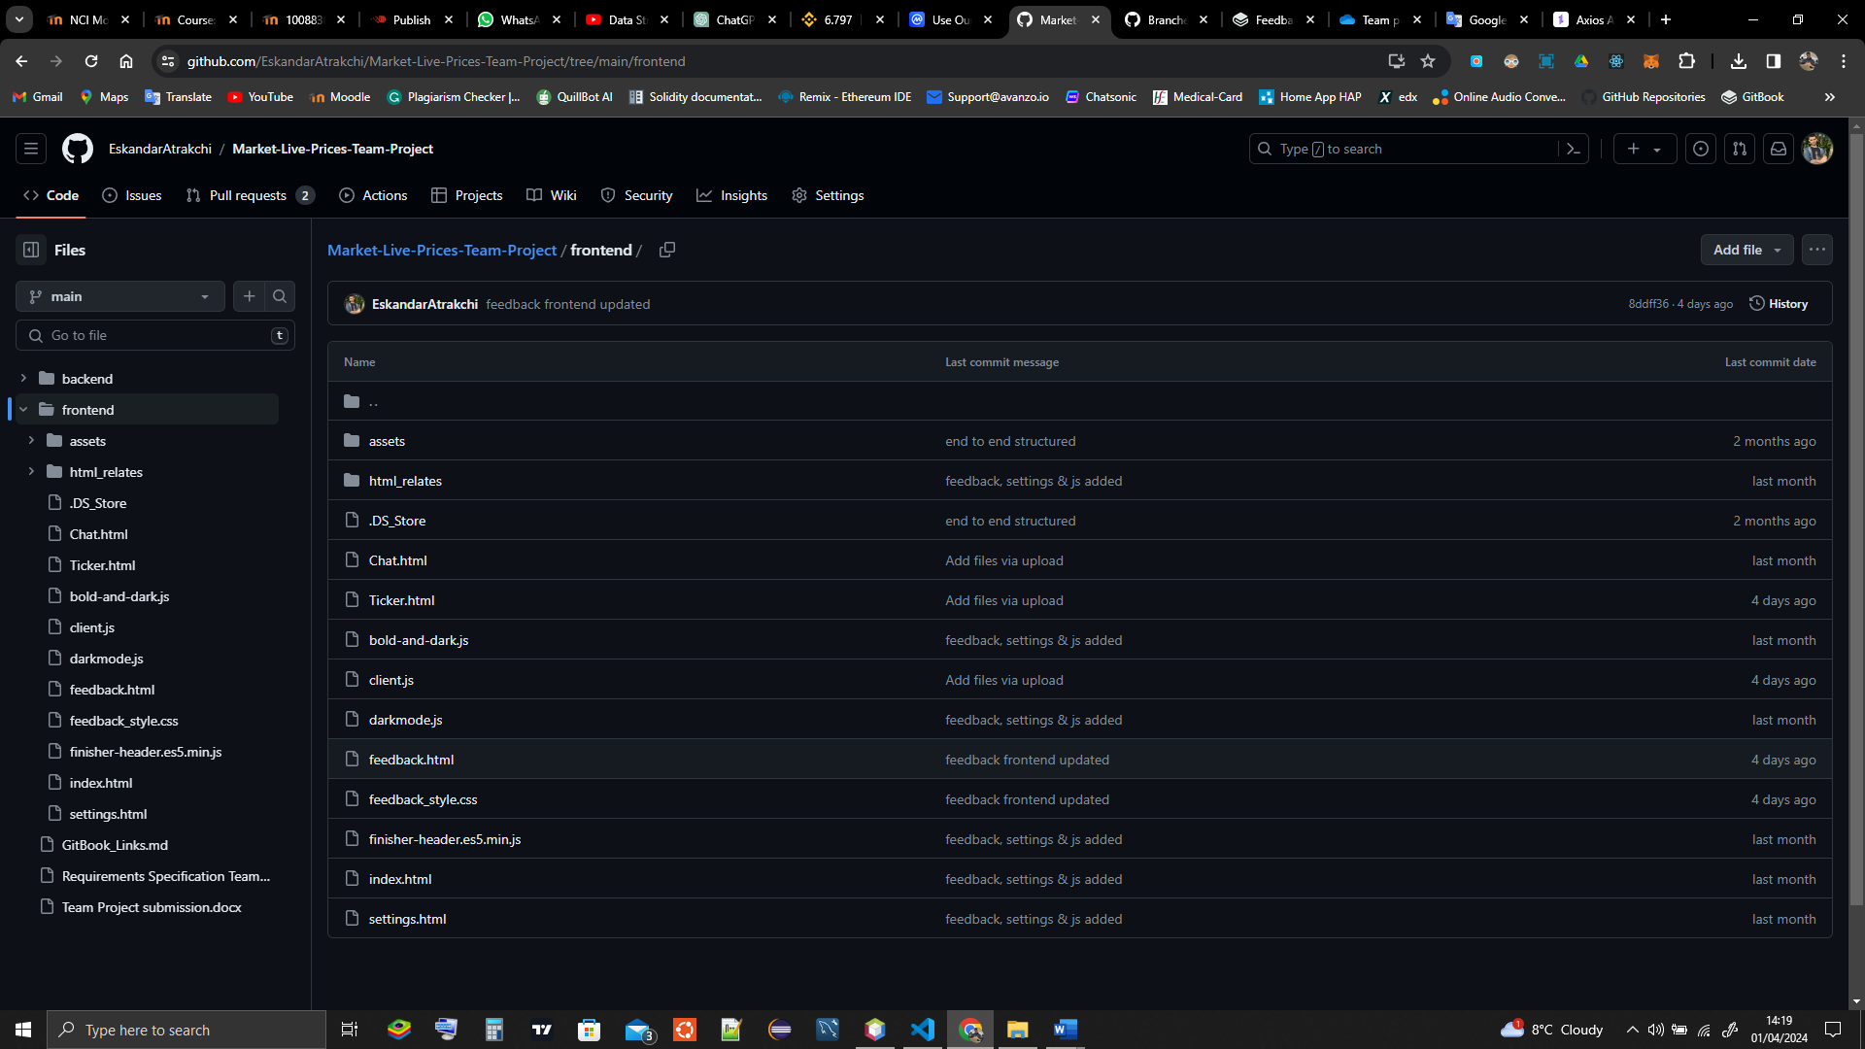  
     
   This is the structure of the frontend.   
   We have used bootstrap and chart.js for dynamic chart rendering   
   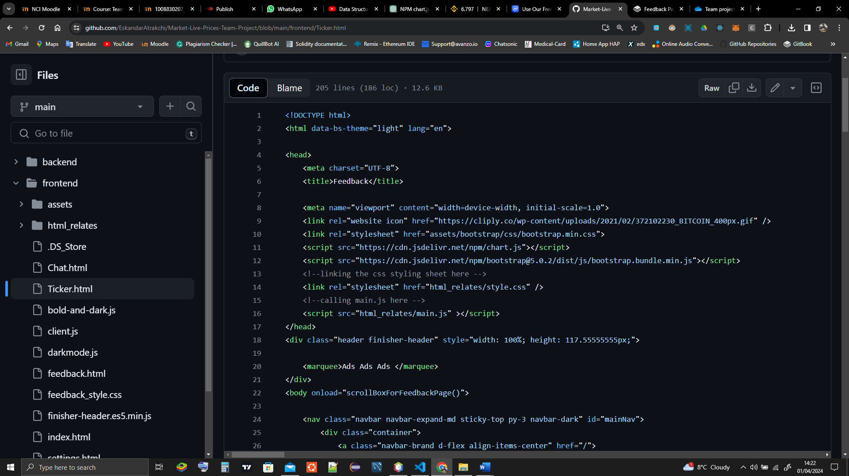  
     
   the purpose of bootstrap is to handle the webpages in different screen sizes and for better styling library.  
   The frontend can run on GitHub pages or any server, we might deploy it on GitHub pages when it is finished.

## Graphical User Interface (GUI)

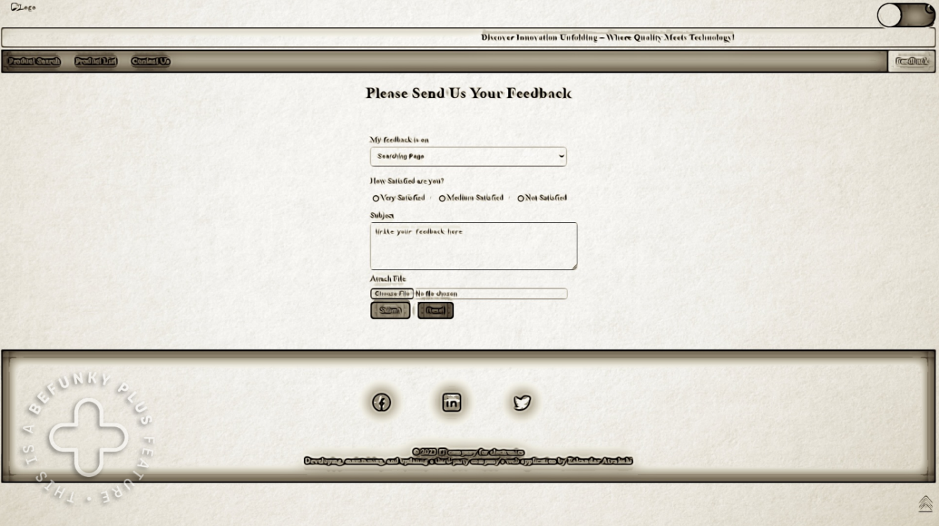

Feedback page

The navbar is to route the user to other pages, we will include nice footer for the user that includes useful links so that the user can get more information about the markets, all pages are linked as the user can chat about crypto currencies, check the market status or specific currency, chats, and send categorized feedback.

The price retrieval GUI will be designed with a clean and intuitive layout, ensuring ease of navigation for users. It will follow below designs for a positive user experience.

User will search for one or more by names and then the output will be displayed by the table and graph will be shown below this will help the user gain the information along with visual data.

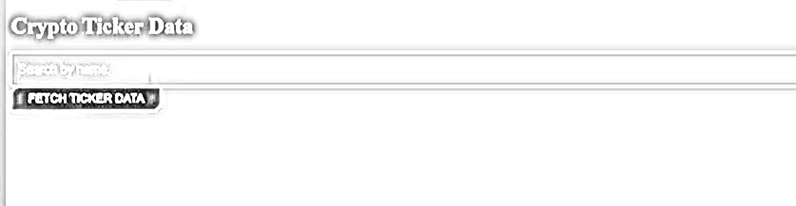

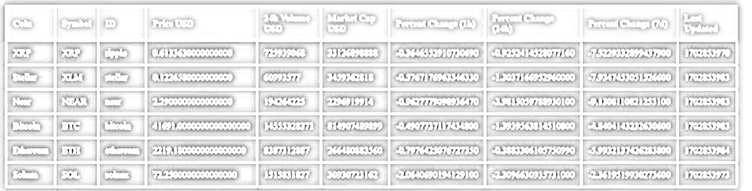

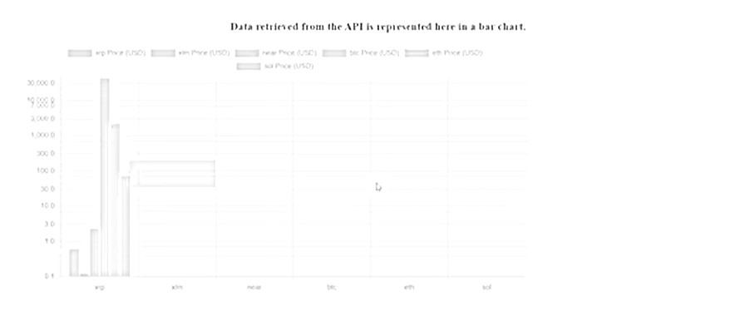

The users can retrieve the ID number for any cryptocurrency that exists in the crypto market. Fear and Greed index of the whole crypto market indicates. Integrating crypto bubbles frame by using API. Users can see the frame of crypto bubbles from the webpage.

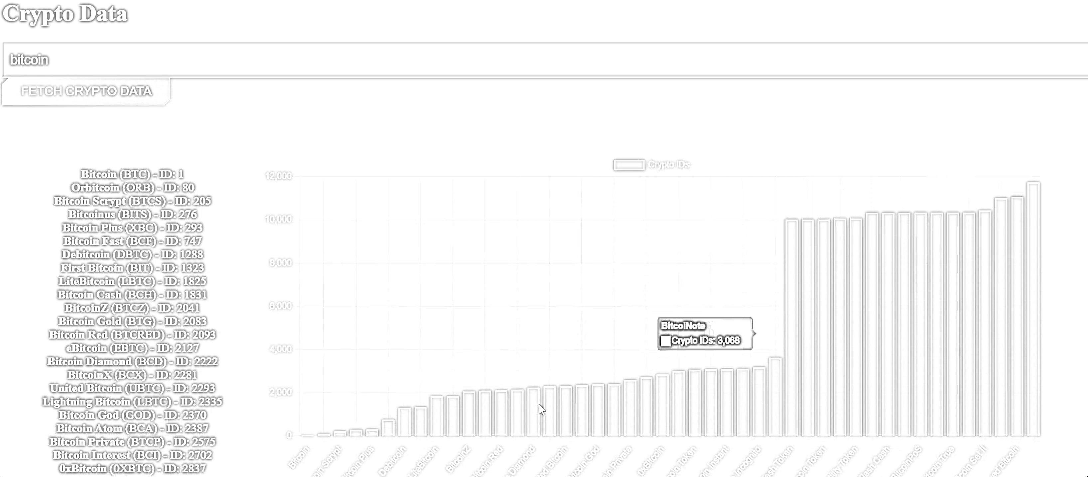

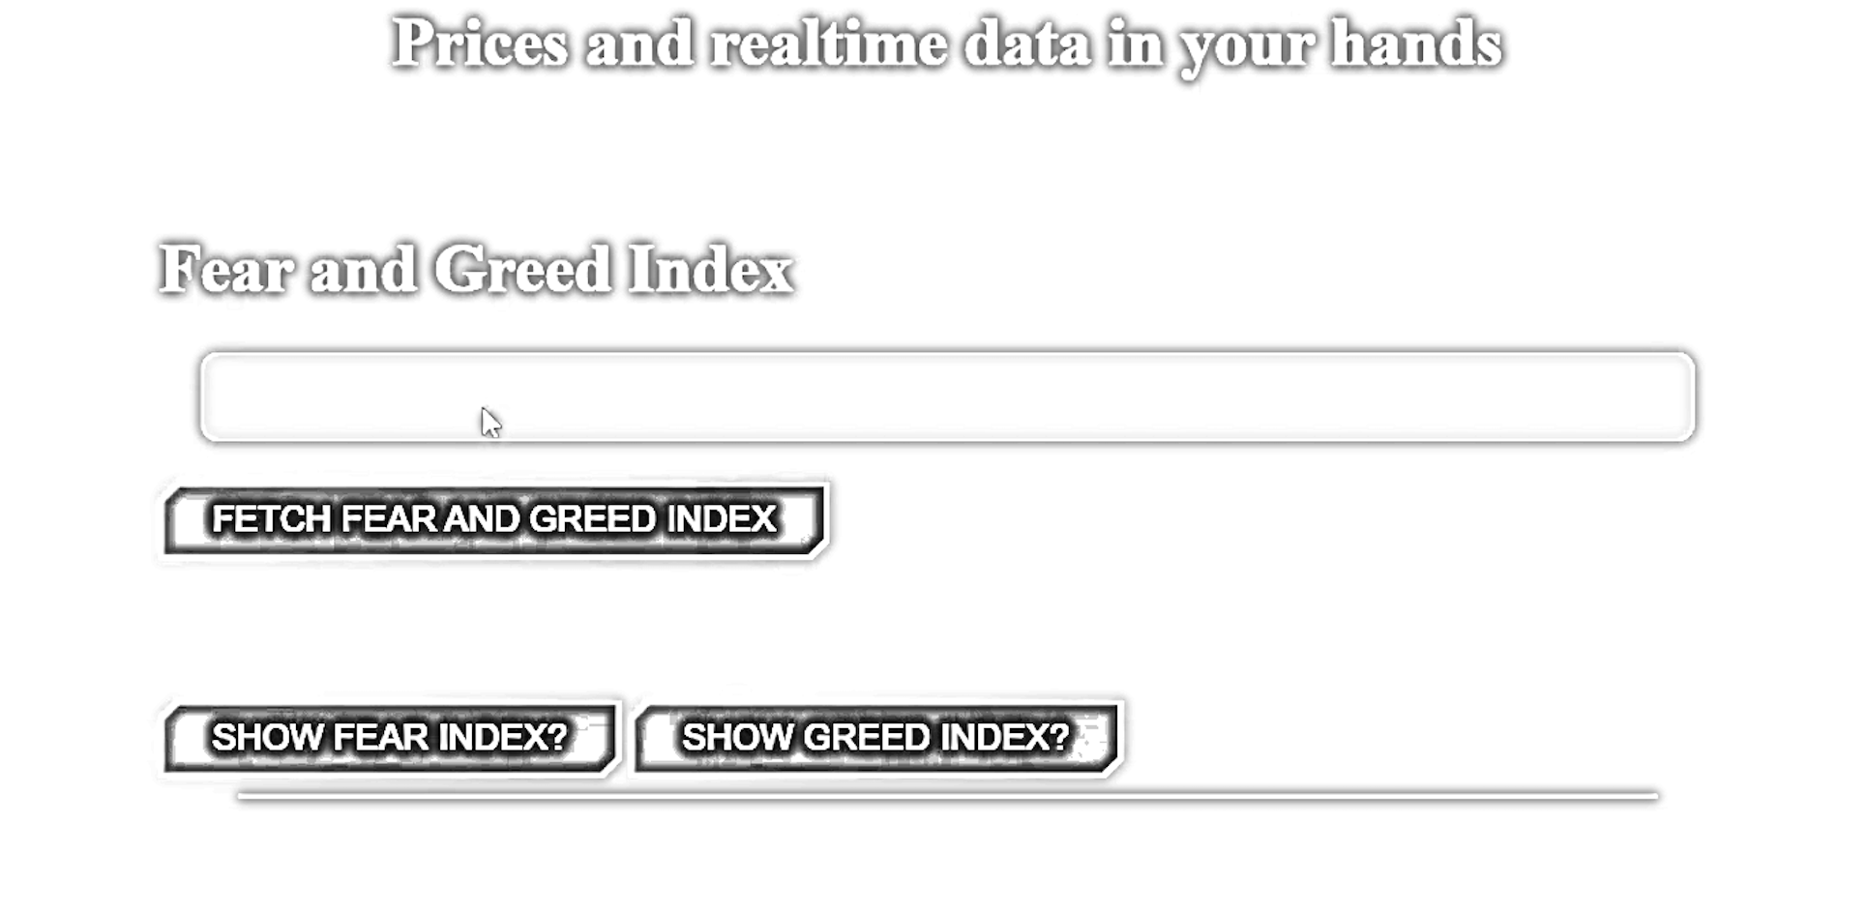

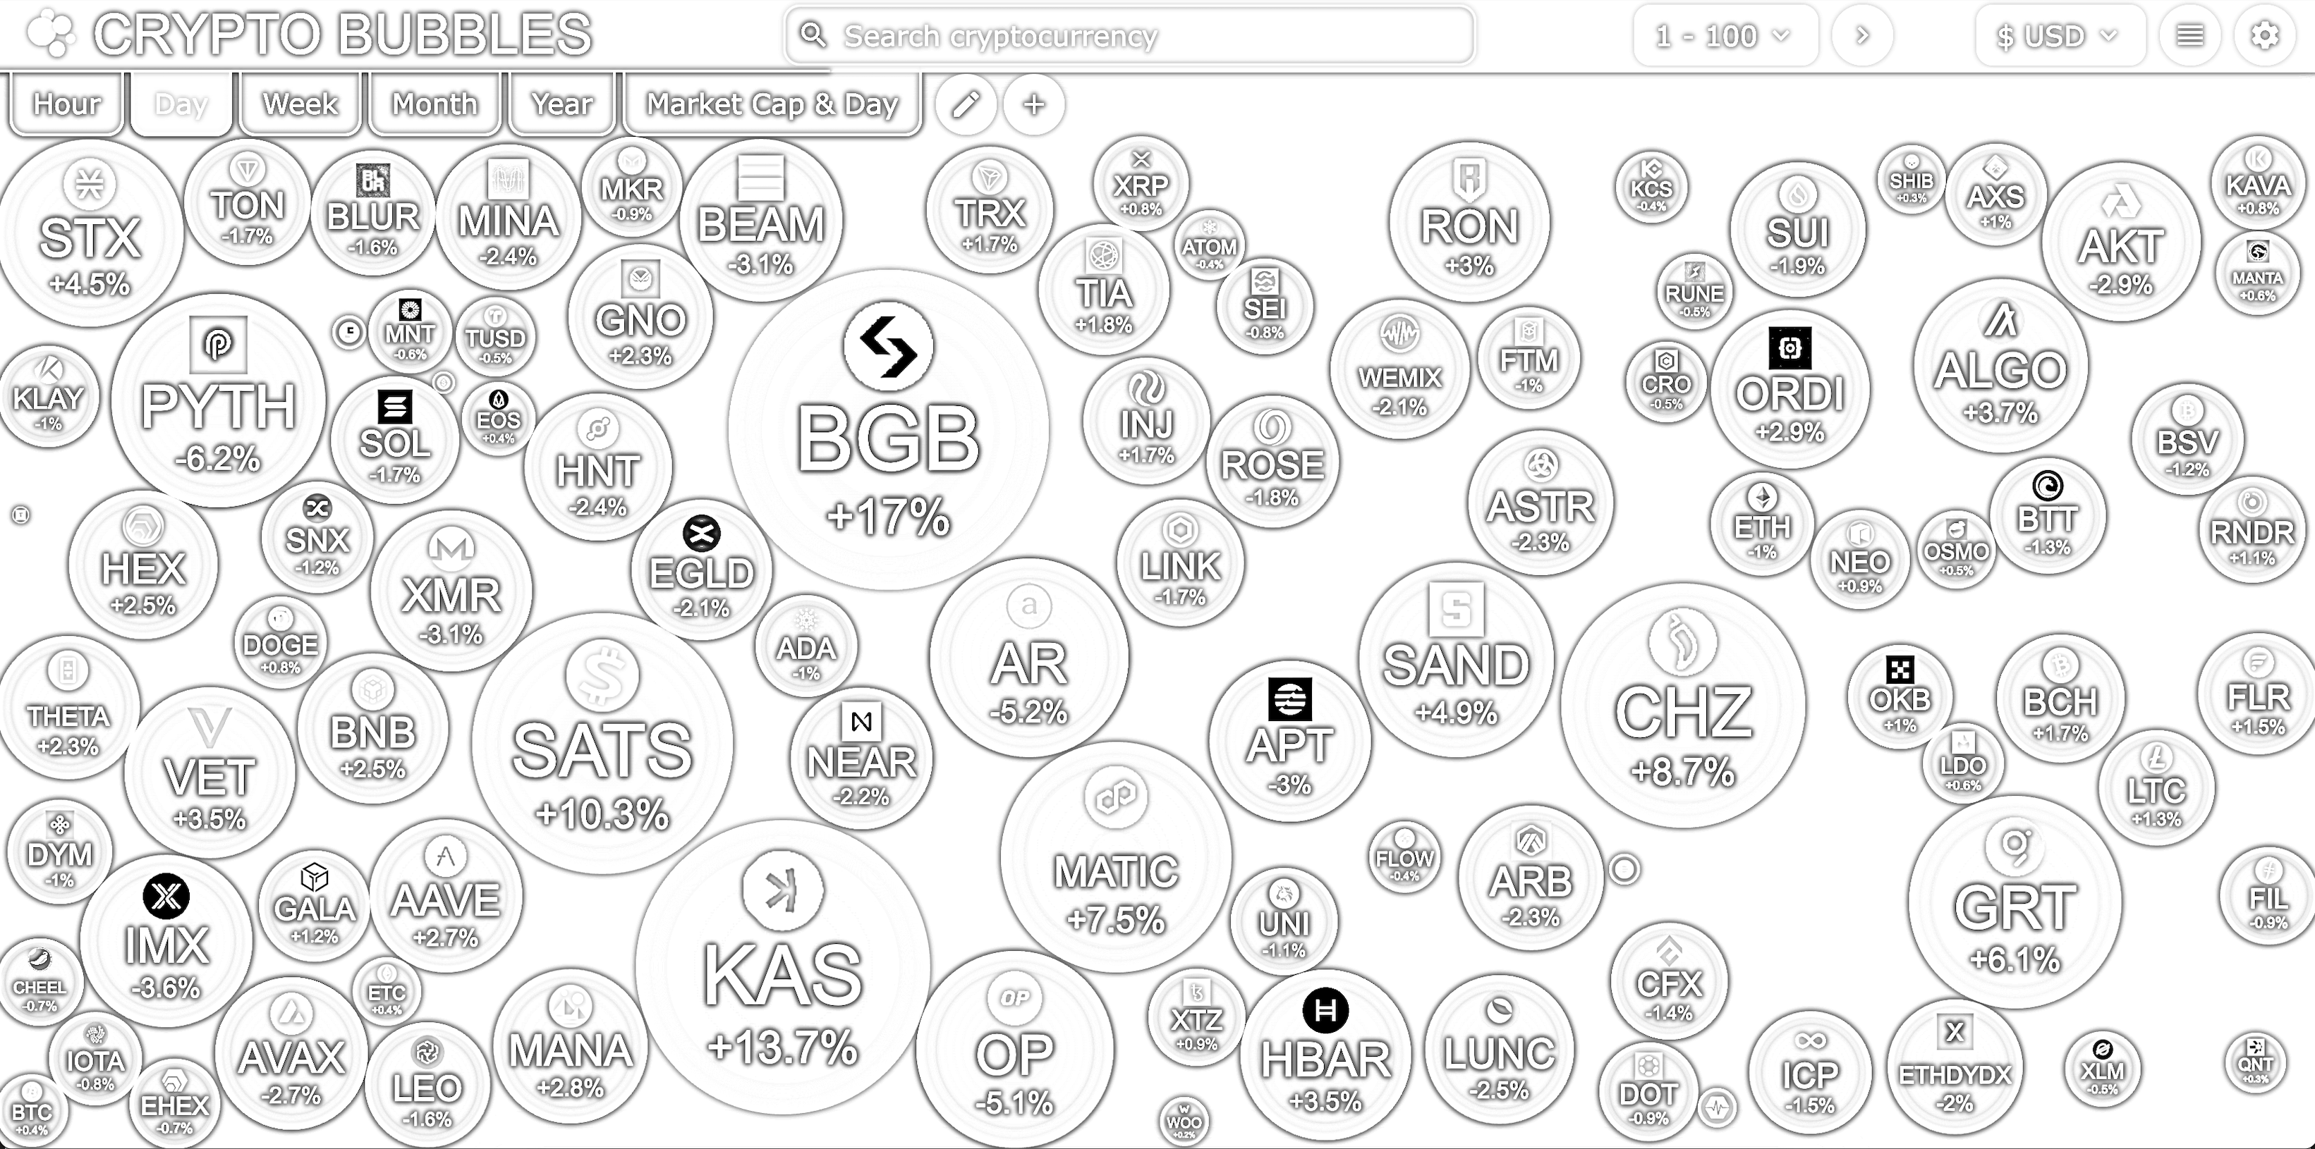

## Testing

We have done the black box testing on the project and white box testing while coding it along the way   
<https://github.com/EskandarAtrakchi/WebDev-project-2-NCI-Year-2/raw/main/WebDev%20API%20Test%20plan.xlsx>

This link will take you to excel sheet that shows the testing has been done on the pages.  
We have used excel to document the testing, however, we have not used the automated testing yet as we are coding in JavaScript not Java, we will do the automated testing as soon as we figure out how to automate JavaScript coded project working in harmony with multiple other languages and JavaScript libraries.

# Further Development

With very impressive movements, this project can lead the development of trading digital financial assets, people can do actually make trading decision based on our website, considering that, this means we will lead millions of dollars in trading volumes if we make this correct!

# References

* NPM. (n.d.). chart.js. [online] Available at: <https://www.npmjs.com/package/chart.js?activeTab=readme> [Accessed 1 April 2024].
* NPM. (n.d.). cors. [online] Available at: <https://www.npmjs.com/package/cors> [Accessed 1 April 2024].
* Express. (n.d.). Installing Express. [online] Available at: <https://expressjs.com/en/starter/installing.html> [Accessed 1 April 2024].
* NPM. (n.d.). nodemon. [online] Available at: <https://www.npmjs.com/package/nodemon> [Accessed 1 April 2024].
* Axios. (n.d.). API Introduction. [online] Available at: <https://axios-http.com/docs/api_intro> [Accessed 1 April 2024].

# Appendices

This section should contain information that is supplementary to the main body of the report.

## Collaboration Summary

|  |  |  |
| --- | --- | --- |
| **Dev Name** | **Dev-Branch** | **Main** |
| [Eskandar-StudentNo.23137517](https://github.com/EskandarAtrakchi/Market-Live-Prices-Team-Project/tree/Eskandar-StudentNo.23137517) | <https://github.com/EskandarAtrakchi/Market-Live-Prices-Team-Project/commits/Eskandar-StudentNo.23137517> | <https://github.com/EskandarAtrakchi/Market-Live-Prices-Team-Project/commits?before=8ddff36abe9f142d5523d0cf325c0c2ac2a48077+35&author=EskandarAtrakchi> |
| [Alex-StudentNo.22440482](https://github.com/EskandarAtrakchi/Market-Live-Prices-Team-Project/tree/Alex-StudentNo.22440482) | <https://github.com/EskandarAtrakchi/Market-Live-Prices-Team-Project/commits/Alex-StudentNo.22440482> | <https://github.com/EskandarAtrakchi/Market-Live-Prices-Team-Project/commits/main?author=NCIAlexGar> |
| [Joshua-StudentNo.23153920](https://github.com/EskandarAtrakchi/Market-Live-Prices-Team-Project/tree/Joshua-StudentNo.23153920) | <https://github.com/EskandarAtrakchi/Market-Live-Prices-Team-Project/commits/Joshua-StudentNo.23153920> | <https://github.com/EskandarAtrakchi/Market-Live-Prices-Team-Project/commits/main/Joshua-StudentNo.23153920> |
| [Yonas-StudentNo.23154454](https://github.com/EskandarAtrakchi/Market-Live-Prices-Team-Project/tree/Yonas-StudentNo.23154454) | <https://github.com/EskandarAtrakchi/Market-Live-Prices-Team-Project/commits/Yonas-StudentNo.23154454> | <https://github.com/EskandarAtrakchi/Market-Live-Prices-Team-Project/commits/main?author=yonas255> |